##### BAIT1023 Web Design and Development

**Assignment**

| **Programme : BAIT1023 Web Design and Development** |
| --- |
| **Tutorial Class : REIS3G1** |
| **Practical Tutor Name: Mr.Chong Kah Shiu** |
| **Website Title: SportoSense** |
| | **No.** | **Student Name** | **Student ID** | **Module In Charge** | **Signature** | **Part A**  **(30%)** | **Part B**  **(70%)** | **Total**  **(100%)** | | --- | --- | --- | --- | --- | --- | --- | --- | | **1** | **Darren Ong Jungai** | **2102991** | **Product, Clothing** | **DOJ** |  |  |  | | **2** | **Chuang Kian Hui** | **2102235** | **Homepage, About Us, Wishlist, FAQ** | **KH** |  |  |  | | **3** | **Jason Lee Yip Siong** |  |  |  |  |  |  | | **4** | **Soh Chiu Yi** |  |  |  |  |  |  | | **5** | **Tee Pei Wen** | **2102604** | **Cart, Checkout, Payment** | **daphne** |  |  |  | |
| **Date of Submission:16/4/2022** |

**Assessment Rubrics – Assignment Part 1 (30 marks)**

| **CLO2: Present the design and implementation of a Website by applying the acquired knowledge and skills in a team. (A2, PLO4)** | | | | | |
| --- | --- | --- | --- | --- | --- |
| **Criteria** | **Marks** | **Good** | **Average** | **Poor** | **Score** |
| Planning   * Description of the organization * Web site objectives * Potential users * Information the users need * Proposed deliverable | 8 | Correctly & clearly define all of the required information.  (7 – 8) | Correctly define most of the required information. Few are either incorrect or missing.  ( 5– 6) | Most of the information is missing, incomplete or incorrect.  (0 – 4) |  |
| Analysis   * Functions or modules | 6 | Excellently define all the required information of web site modules correctly & clearly.  (5 – 6) | Correctly define most of the required information web site modules correctly. Few are either incorrect or missing.  (3– 4) | Most of the web site module information is incomplete or incorrect.  (0 – 2) | | Name | Mark | | --- | --- | | 1. Darren Ong Jungai |  | | 2.Chuang Kian Hui |  | | 3.Jason Lee Yip Siong |  | | 4.Soh Chiu Yi |  | | 5.Tee Pei Wen |  | |
| Design   * Web page layout design | 6 | Excellently define all the required information. All sketches are clear and easy to read.  (5 – 6) | Correctly define most of the required information. Few are either incorrect or missing. Some sketches is not clear/hard to read.  (3 – 4) | Most of the information is missing, incomplete or incorrect, most sketches are not clear/ hard to read.  (0 –2) | | Name | Mark | | --- | --- | | 1. Darren Ong Jungai |  | | 2.Chuang Kian Hui |  | | 3.Jason Lee Yip Siong |  | | 4.Soh Chiu Yi |  | | 5.Tee Pei Wen |  | |
| Web development management | 10 | Work together with different team member in completing web site and system documentation effectively and on time.  (8-10) | Work together with different team member in completing the completing web site and system documentation on time.  (5– 7) | Work together with different team member in completing web site and system documentation  ineffectively and late.  (0 – 4) |  |
| Comments (if any): | | | | | | **Name** | **Total Mark (Part 1)** | | --- | --- | | 1. Darren Ong Jungai |  | | 2.Chuang Kian Hui |  | | 3.Jason Lee Yip Siong |  | | 4.Soh Chiu Yi |  | | 5.Tee Pei Wen |  | |  |  | |

**Assessment Rubrics – Assignment Part 2 (70 marks)**

| **CLO1: Build a website with HTML, Cascading Style Sheets (CSS) , JavaScript and web development tools. (P4, PLO3)** | | | | | |
| --- | --- | --- | --- | --- | --- |
| **Criteria** | **Marks** | **Good** | **Average** | **Poor** | **Score** |
| Functionality & Complexity of the Overall Web Site using the following elements**:**   * Media elements (text, graphic, audio, video and animation) * Hypertext and hypermedia * List * Formatting * Hotspot / image map * Table * Form * CSS for all of the GUI design (use External Style Sheet effectively) * JavaScript | 40 | Excellently completed more than 80% of the required functionalities correctly using all the listed elements.  (30 – 40) | Averagely completed more than 50% of the required functionalities with some minor errors. Only used some of the listed elements.  (16 – 29) | Not able to complete most of the required functionalities correctly. Only used few of the listed elements.  (0 – 15) |  |
| Usability & User Interface Features | 30 | Good design consistency and interface usability, visual effect and interactivity.  (23 – 30) | Average design, consistency and interface usability, visual effect and interactivity  (12 – 22) | Poor design, consistency and interface usability, visual effect and interactivity.  (0 –11) | | Name | Mark | | --- | --- | | 1. Darren Ong Jungai |  | | 2.Chuang Kian Hui |  | | 3.Jason Lee Yip Siong |  | | 4.Soh Chiu Yi |  | | 5.Tee Pei Wen |  | |
| Comments (if any):  **______________________________________________________________________________________** | | | | | | **Name** | **Total Mark (Part 2)** | | --- | --- | | 1. Darren Ong Jungai |  | | 2.Chuang Kian Hui |  | | 3.Jason Lee Yip Siong |  | | 4.Soh Chiu Yi |  | | 5.Tee Pei Wen |  | |  |  | |

**Description of the organization**

SportoSense is a new sportswear retail brand that cooperates mainly with Adidas to promote and sell their sportswear including sports shirts, pants, shoes and accessories. We have our own professional team in charge of marketing and sales to have an effective plan and develop a website to attract consumers’ attention and increase product sales. We highly emphasize our consumers’ experience and always work hard to provide the best products and services to them. As sports play an important role in more and more people's lives, the need or demand for good sportswear is also increasing. Our main focus is to introduce the best quality Adidas sportswear to the consumers in order for them to do their favorite sports in comfort and have the best experience with them. Our mission is to become one of the best sportswear retail brands in the industry.

**Website Objectives**  
 The main objective of this website is to build a brand. The brand is a set of unique values for an organization, it represents the reputation of the business. For a start, we will create a logo, which is the symbol of our brand. We will put out our products, the design of the products, the messages that we want to deliver to the website users, and our organizational culture on the website. On the whole, the output is called a brand. Besides that, this website will help to improve the business process automation by establishing a strong connection between the marketing team and sales team which will enable the business operation to be made seamless online using the website platform. Moreover, the objective of this website is to improve the SEO of the products. We would optimize our website and increase traffic to our website by using Search Engine Optimization (SEO). The biggest factor of Google to determine which website should appear on the first page as the result of searching is relevancy. In addition to relevance, we would also want to make sure that our website is useful. All that means is that when a user clicks on the website, the information that they are looking for is easily found. SEO would greatly help an organization to increase sales by turning the leads into customers.

**Potential users of the Website**

**1. Working Adults**

* They can use this website to search for suitable shoes for work. In fact, different gender working adults can use this website to buy any product as a gift for their loved ones or families such as sport shoe and sports tees. This website can help them to make their purchase easily without costing them too much time.

**2. Teenagers**

* Nowadays there are a lot of teenagers who love to wear sports shoes to attend any occasion such as a party or events. They can use this website to look for their favorite sports shoes conveniently.

**3. Sports lovers**

* They can look for anything they want on this website such as sports accessories, sports pants, sports tee and sports shoes. They will have more choices and find out which one is the most comfortable for them.

**4. Purchasing agents or resellers**

* Those interested in working as a reseller or purchasing agents will have a new opportunity to start a new job or business by using this website.

**5. Shoe collectors**

* They can look for their favorite kind of shoes and catch up with the latest trends to collect all of them.

**Information the users need and wants**

The information of users’ needs and wants are stated below:

1. Adidas product brands on the website.
2. The price and specifications of each product.
3. Different types of shipment for products.
4. Phone number and email address of the customer service.
5. The introduction of the entire company or organization. (company address, types of organization)
6. The membership details and application. (description, discount offered, annual fees)
7. Customer feedback on web page design and products.
8. FAQ provided to get more information.
9. Various payment types while checkout.
10. Promotions that are listed on the website.

| Task name | Start date | End date | Duration | Assigned | WEEK 1 | WEEK 2 | WEEK 3 | WEEK 4 | WEEK 5 | WEEK 6 | WEEK 7 | WEEK 8 | WEEK 9 |
| --- | --- | --- | --- | --- | --- | --- | --- | --- | --- | --- | --- | --- | --- |
| **Preparatory Work** | **15/2/2022** | **1/3/2022** | **Week 1 - 2** | **All Members** |  |  |  |  |  |  |  |  |  |
| Folder Structure | 15/2/2022 | 22/2/2022 |  |  |  |  |  |  |  |  |  |
| Page Resources | 15/2/2022 | 22/2/2022 |  |  |  |  |  |  |  |  |  |
| Common Layout/Style | 22/2/2022 | 1/3/2022 |  |  |  |  |  |  |  |  |  |
| Chapter 1: Planning | 22/2/2022 | 1/3/2022 |  |  |  |  |  |  |  |  |  |
|  |  |  |  |  |  |  |  |  |  |  |  |  |  |
| **Individual Work** | **1/3/2022** | **16/4/2022** | **Week 3 - 9** |  |  |  |  |  |  |  |  |  |  |
| Homepage Module | 1/3/2022 | 5/4/2022 |  | Kian Hui |  |  |  |  |  |  |  |  |  |
| Product Module | 1/3/2022 | 5/4/2022 |  | Darren |  |  |  |  |  |  |  |  |  |
| - Shoe Module | 1/3/2022 | 5/4/2022 |  | Jason |  |  |  |  |  |  |  |  |  |
| - Clothing Module | 1/3/2022 | 5/4/2022 |  | Darren |  |  |  |  |  |  |  |  |  |
| - Accessories Module | 1/3/2022 | 5/4/2022 |  | Chiu Yi |  |  |  |  |  |  |  |  |  |
| Promotion Module | 1/3/2022 | 5/4/2022 |  | Chiu Yi |  |  |  |  |  |  |  |  |  |
| Membership Module | 1/3/2022 | 5/4/2022 |  | Chiu Yi |  |  |  |  |  |  |  |  |  |
| Cart Module | 1/3/2022 | 5/4/2022 |  | Pei Wen |  |  |  |  |  |  |  |  |  |
| Checkout Module | 1/3/2022 | 5/4/2022 |  | Pei Wen |  |  |  |  |  |  |  |  |  |
| Payment Module | 1/3/2022 | 5/4/2022 |  | Pei Wen |  |  |  |  |  |  |  |  |  |
| Feedback Module | 1/3/2022 | 5/4/2022 |  | Kian Hui |  |  |  |  |  |  |  |  |  |
| FAQ Module | 1/3/2022 | 5/4/2022 |  | Kian Hui |  |  |  |  |  |  |  |  |  |
| Wishlist Module | 1/3/2022 | 5/4/2022 |  | Kian Hui |  |  |  |  |  |  |  |  |  |
| Terms and Conditions Module | 1/3/2022 | 5/4/2022 |  | Chiu Yi |  |  |  |  |  |  |  |  |  |
| **Website Testing** |  |  |  |  |  |  |  |  |  |  |  |  |  |
|  |  |  |  |  |  |  |  |  |  |  |  |  |  |
| **Publication** |  |  |  |  |  |  |  |  |  |  |  |  |  |
|  |  |  |  |  |  |  |  |  |  |  |  |  |  |
|  |  |  |  |  |  |  |  |  |  |  |  |  |  |
|  |  |  |  |  |  |  |  |  |  |  |  |  |  |
|  |  |  |  |  |  |  |  |  |  |  |  |  |  |
|  |  |  |  |  |  |  |  |  |  |  |  |  |  |
|  |  |  |  |  |  |  |  |  |  |  |  |  |  |

2.0 Functions or Modules For This Website

**Homepage**

This page is to

**About Us Page**

This page is to

**Wishlist Page**

This page is to

**FAQ Page**

This page is to

**Product Page**

2.0 Functions or Modules For This Website **Membership Page**This page includes the introduction which explains what are the reasons for choosing SportoSense, information about the benefits of joining SportoSense as a member and frequently asked questions about SportoSense membership. In the introduction field, it provides the button of ‘Sign Up’ at the end of the introduction, which will lead the user to the SignUp page and proceed with their signup action. The second part of the membership page is about the benefits of membership. There is a clear explanation of each benefit of SportoSense members. For membership FAQ, with the use of responsive FAQ accordion dropdown, the questions are shown but the user won’t be able to see the answer yet. They need to click on each question then it will expand and the answer is shown. It will collapse again if they click on another question.   
  
**SignUp Page**This page can be accessed by a link from the Membership page. New members must fill out their username, email address, date of birth and password, while existing members may log in using their password and username from the login page.  **Accessories Page**This page is **Promotion Page**This page is **Terms and Condition Page**  
This page is

**Cart Page**

The page is to record all the products' details including price, quantity, image and name that customers intend to purchase. There are several functions that customers can do in this module. Firstly, customers can increase or decrease the quantity that wants to buy for each product in the cart and also can directly input the quantity. Secondly, the page will calculate and display the subtotal that includes shipping fees, products total and the grand total of the cart before proceeding to checkout. Once they have decided to purchase the specific products, they can proceed to the checkout page by clicking the checkout button.

**Checkout Page**

The page is displayed when the customer clicks on the checkout button on the cart page. Customers are required to fill up the shipping address form. The purpose of this form is to record the customers’ addresses for delivery. There are several required fields that need to be entered by customers such as Full Name, Email, Address, City, State and Postcode. The right-hand side will display the cart summary for customers. The coupon code field is provided for the customer who had redeemed a birthday code to apply and get 10% discount. Next, there is the payment method field that allowed customers to choose their payment method. When the customer clicked on Cash On Delivery button, the page will be redirected to the billing address page. If the customer clicked on the online banking button, there will be a div shown for the customer to select the banks. If the customer clicked on the credit/debit card button, the page will be redirected to the payment page. Lastly, there is a confirm checkout button for customers to submit the form.

**Payment Page**

This page is directed from the checkout page after the customer clicked on credit/debit card payment button. Customers need to fill in all the details on the required fields.

The fields that need to be filled:

1. Name on card
2. Card number
3. Exp Month
4. Exp Year
5. Card Verification Value (CVV)

Lastly, customers clicked on confirm payment button to submit the payment.

**Billing Page**

This page is directed from the checkout page after the customer clicked on cash on delivery payment button. The purpose of this page is to record the billing address of customers for cash on delivery invoice receipts. Customers need to fill in the details on the required fields.

The fields that need to be filled:

1. Full Name
2. Email
3. Address
4. City
5. State (select)
6. Postcode

Lastly, customers clicked on confirm payment button to submit the payment and pay by cash when goods are received by customers on the spot.

3.0 Design of Webpage

**Homepage (Chuang Kian Hui)**

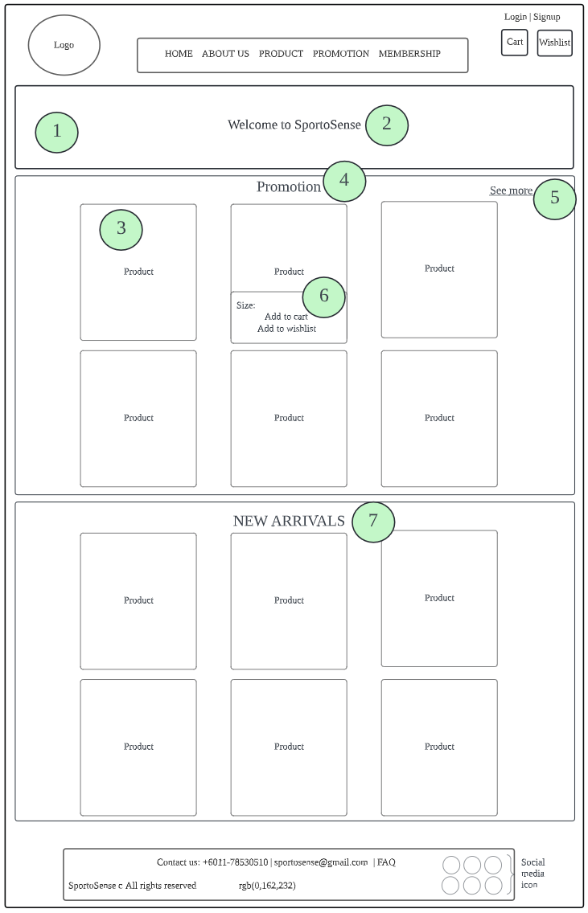

**About Us Page (Chuang Kian Hui)**

**Wishlist Page (Chuang Kian Hui)**

**FAQ Page (Chuang Kian Hui)**

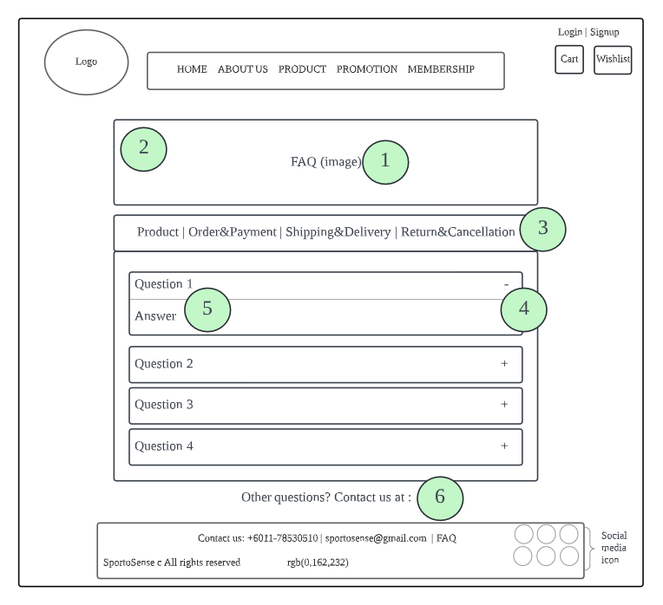

**Product Page (Darren)**

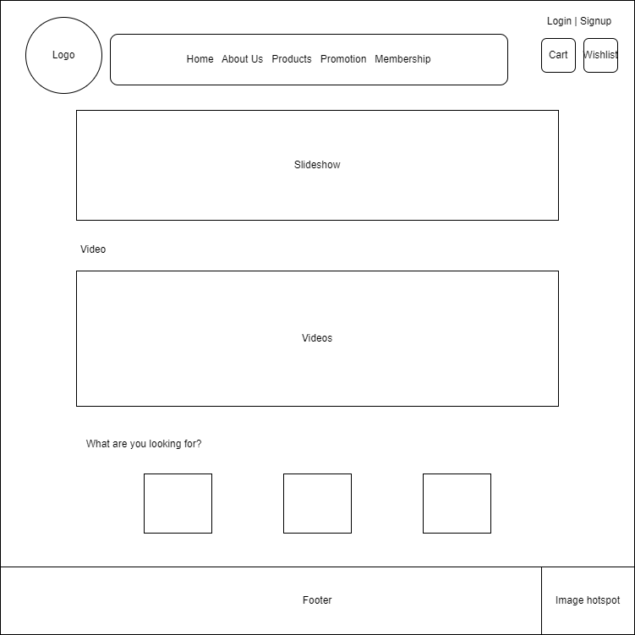

**Shoe Page (Darren)**

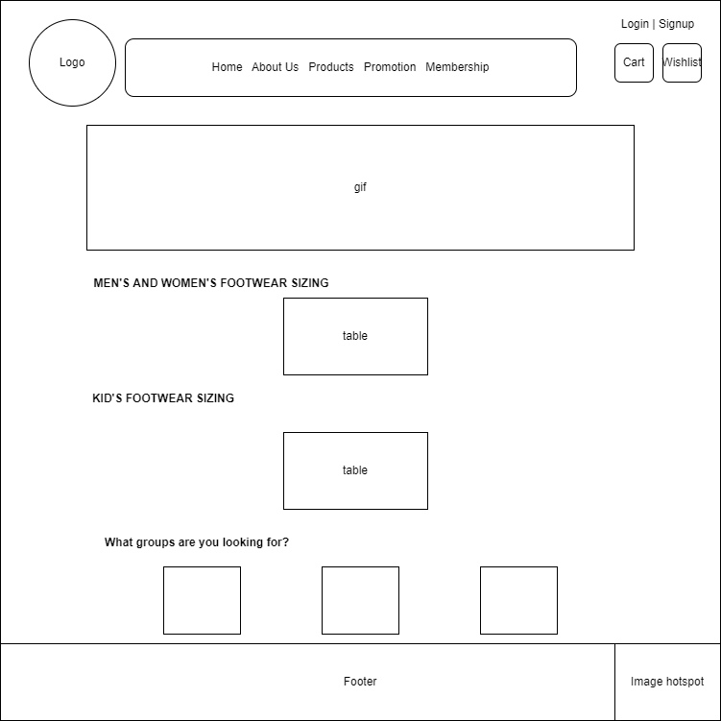

**Clothing Page (Darren)**

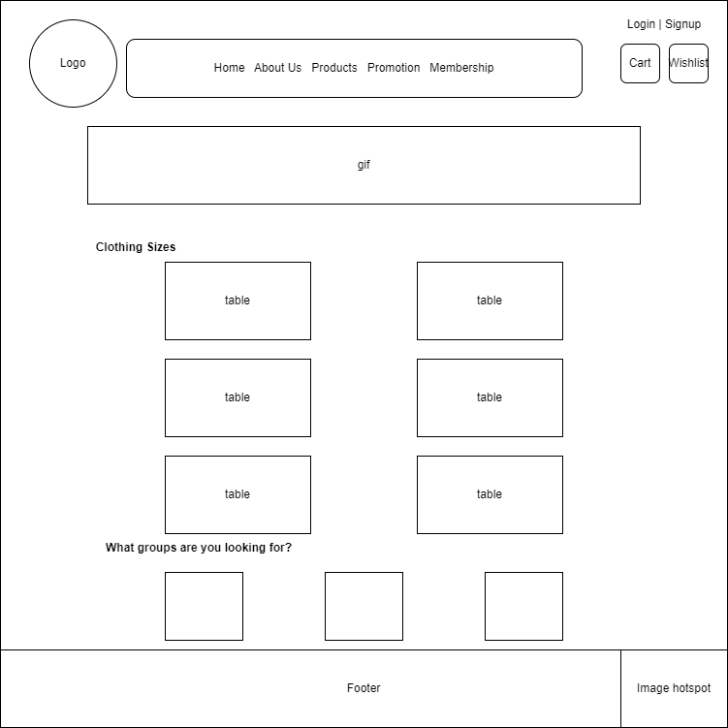

**Clothing Display Page (Darren)**

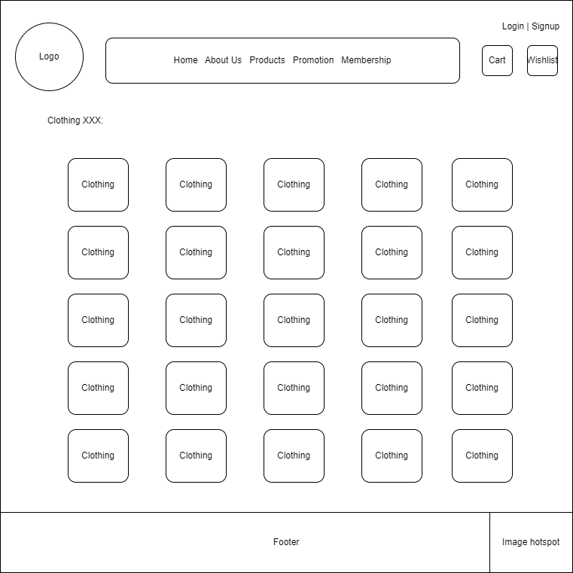

**Cart Page (Tee Pei Wen)**

**Description of Cart Page**

| No | Name | Description |
| --- | --- | --- |
| 1 | Quantity | Change quantity by increase or decrease or directly input. |
| 2 | Product name | The place to display product name that helps customers to identify the product. |
| 3 | Price | Shows the price quoted for each product and the customer is not easily confused. |
| 4 | Page Title | Represents the page functions. It must be large font size and bold to clearly present. |
| 5 | Remove | A button to remove a product from the cart. |

**Checkout Page (Tee Pei Wen)**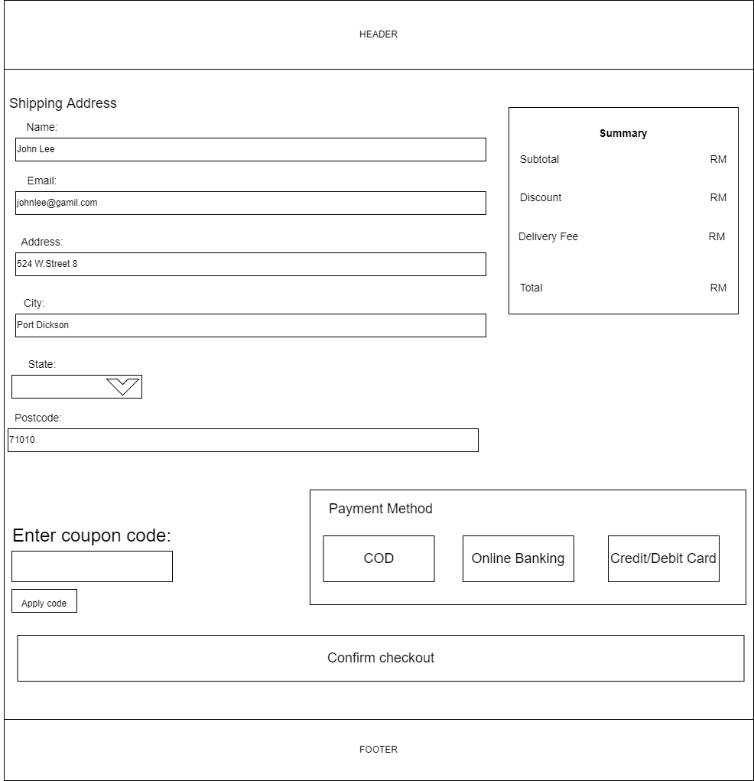



















**Description of Checkout Page**

| No | Name | Description |
| --- | --- | --- |
| 1 | Name Field | This is required to fill and ask users to fill in their name. |
| 2 | Input placeholder | The design is to guide users input the correct format. |
| 3 | Email Field | Let users input their email. This is a required field for organizations to send some promotion advertisements. Validation: must be email format. |
| 4 | Address Field | This is a required field for organizations to deliver the goods to the stated address. |
| 5 | City, and State | Users need to input the city (this is a required field ) and drop-down list select state. |
| 6 | Postcode | Users need to input postcode and this is a required field. Validation: Only 5 digits. |
| 7 | Coupon field | For users who redeemed a birthday code and get 10% discount. |
| 8 | Cash On Delivery | If users choose one of the payment methods which is COD, it will redirect to the Billing Address page. |
| 9 | Online Banking | One of the payment methods, if users click on it, it will display the hidden div which is a selection of banks. |
| 10 | Credit/Debit Card | If the users click this, it will be redirected to the payment page. |
| 11 | Confirm checkout | For the users to submit the checkout form. |

**Payment Page (Tee Pei Wen)**

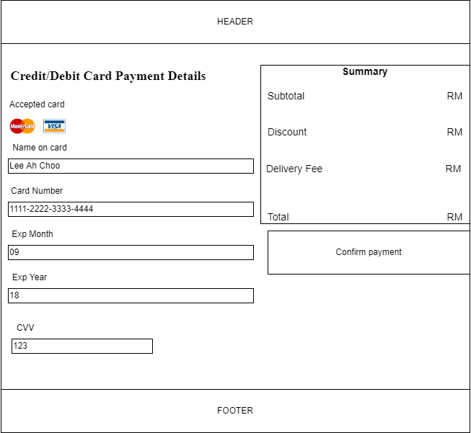















**Description of Payment Page**

| No | Name | Description |
| --- | --- | --- |
| 1 | Name On Card | This is the place where a user is required to enter their name on their credit or debit card. This is a required field. |
| 2 | Card Number | This is a required field. Validation: Only 16 digits. |
| 3 | Exp Month | This is a required field. Input expired month on the card. Validation: Accept only 2 digits. |
| 4 | Exp Year | This is a required field. Input expired year on the card. Validation: Accept only 2 digits. |
| 5 | CVV | Only accept 3-digit numbers from users. This is the required field. |
| 6 | Placeholder | Provide the user with a clue about what to input. |
| 7 | Confirm payment | User click on it to submit the form. |

**Billing Address Page**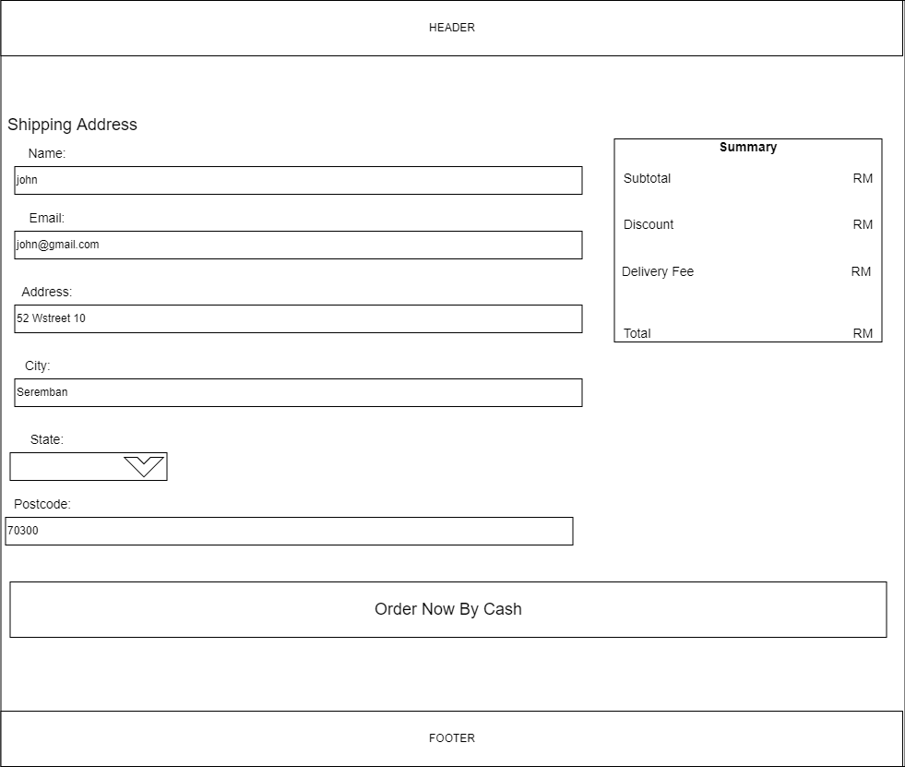

















**Description of Billing Address Page**

| No | Name | Description |
| --- | --- | --- |
| 1 | Name Field | This is required to fill and ask users to fill in their name. |
| 2 | Input placeholder | The design is to guide users input the correct format. |
| 3 | Email Field | Let users input their email. This is a required field for organizations to send some promotion advertisements. Validation: must be email format. |
| 4 | Address Field | This is a required field for organizations to deliver the goods to the stated address. |
| 5 | City, and State | Users need to input the city (this is a required field ) and drop-down list select state. |
| 6 | Postcode | Users need to input postcode and this is a required field. Validation: Only 5 digits. |
| 7 | Order Button | For the users to submit the form. |